Catton Grove Primary School - History
Year: 5 | Topic: History | Key concepts: Mayans
What I should already know:
- Mexico is located in central America
- Mexico has rainforests.
- The Ancient Greeks built pyramids.

Diagram
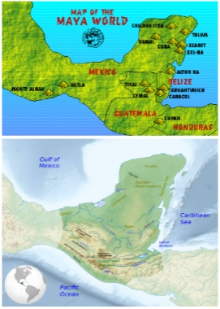

People
- Pakal the Great (K’inich Janaab Pakal) - A king in Mesoamerica whose reign lasted more than 68 years, the longest lasting king in Ancient Maya. He built various intricate temples and was buried with a perfectly preserved jade mask.
Technical Vocabulary
Maya - The collective noun for the Mayan people.
Mesoamerica - The region in which the Maya lived, covering Mexico and parts of Southern America.
Pyramid - A 3D man-made structure that is built through large blocks of rock piled upon one another.
Deity – A synonym for God.
Chichen Itza – One of the best preserved example of a Mayan city.
Legend - A story told that has a religious origin usually comprising of a mortal vs immortal being.
Hieroglyph - A symbol that has a meaning.
Maize - Corn, a major resource of food for Mayan people. Part of their religious culture too.
Sacrifice - A slaughtering of an animal or human as anoffering to please the gods.
Historical Skills and Enquiry
- What caused the decline of the Maya civilisation?
- How important was Pakal the Great to the Maya?
- Who and how did the Maya worship?
- How does the ancient Maya way of life differ to the modern Maya way of life?
- Where do the Maya sit on a historical timeline?
- What can we learn from Mayan hieroglyphs?
Core Knowledge
The Mayan number system was the first in history to use zero, which enabled them to work with much higher numbers than any other ancient civilisation. They worked with a base 20 system as opposed to our base 10 number system.

Chaac was the Mayan god of rain. The Maya believed that thebest way to please their gods was through the sacrifice of animals or humans. If they were experiencing a drought, the belief was that Chaac was punishing them so they would need to sacrifice.

Sacrificing rituals would often be through beheading or
drownings. They were religious ceremonies that many people would attend.

Pok-a-tok was a religious game that was often refereed by the high priest. The players would have to use their bodies to get a ball through a stone hoop. The losing team would sometimes be used as a sacrifice! A lot of Mayan stories would refer to the game of Pok-a-tok.

Headdresses were a large part of Mayan culture. It was believed that the larger the headdress that someone wore, the more important they were.

Pakal the Great was a king in Mesoamerica whose reign lasted more than 68 years, the longest lasting king in Ancient Maya. He built various intricate temples and was buried with a perfectly preserved jade mask.

