**Key Learning**

* To name, locate and identify characteristics of the four countries and capital cities of the United Kingdom and its surrounding seas.
* To identify key human and physical feature of the four countries in the UK.
* To use aerial photographs and plan perspectives to recognise landmarks and basic human and physical features
* To devise a simple map and use basic symbols in a key.
* To use simple compass directions (North, South, East and West)

**Essential Facts**

The UK is made up of 4 countries – England, Wales, Scotland, Northern Ireland.

London is the capital city of England.

Cardiff is the capital city of Wales.

Edinburgh is the capital of Scotland.

Belfast is the capital city of Northern Ireland.

England is a country in the United Kingdom (UK) and in the continent of Europe.

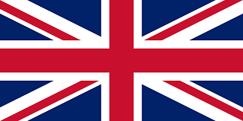**Year 2 Knowledge Organiser**

Autumn 1 – The UK

**Enquiry Questions**

**What are the 4 countries in the UK like?**

What human features do each country have? What is similar? What is different?

What physical features do each country have? What is similar? What is different?

How can we use an aerial map to look for geographical features?

**Geography - What I should already know:**

I know that geography is the study of the world: what it looks like, what it’s made of and what is in it.

I know that human geographical features are features made by people and are not natural. Example include, building,

I know that physical geographical features are features made by nature and not by people.

I know that the world is split into 7 continents.

I know that a city is different to a town and a village.

I know a map contains a key and symbols.

**Key Vocabulary**

Continent, Capital, London, Edinburgh, Belfast, Cardiff, Landmarks, Map, Aerial Map, Symbol, Key

Human features, City, Town, Village, House, Office, Shops

Physical features, Rivers,  Forest, Hill, Mountains

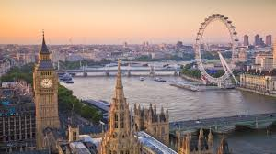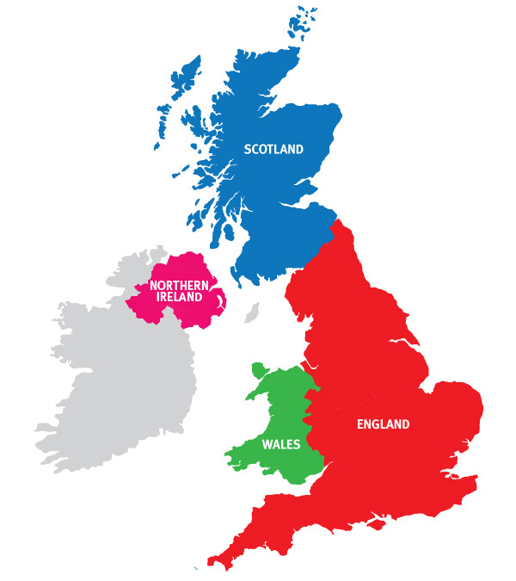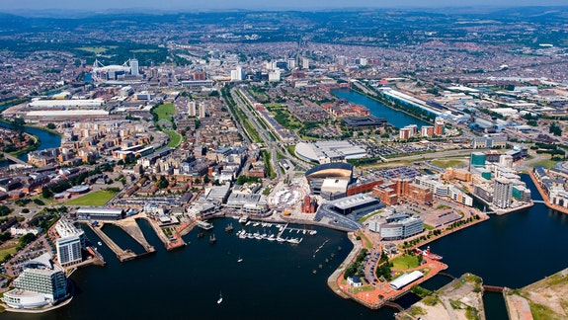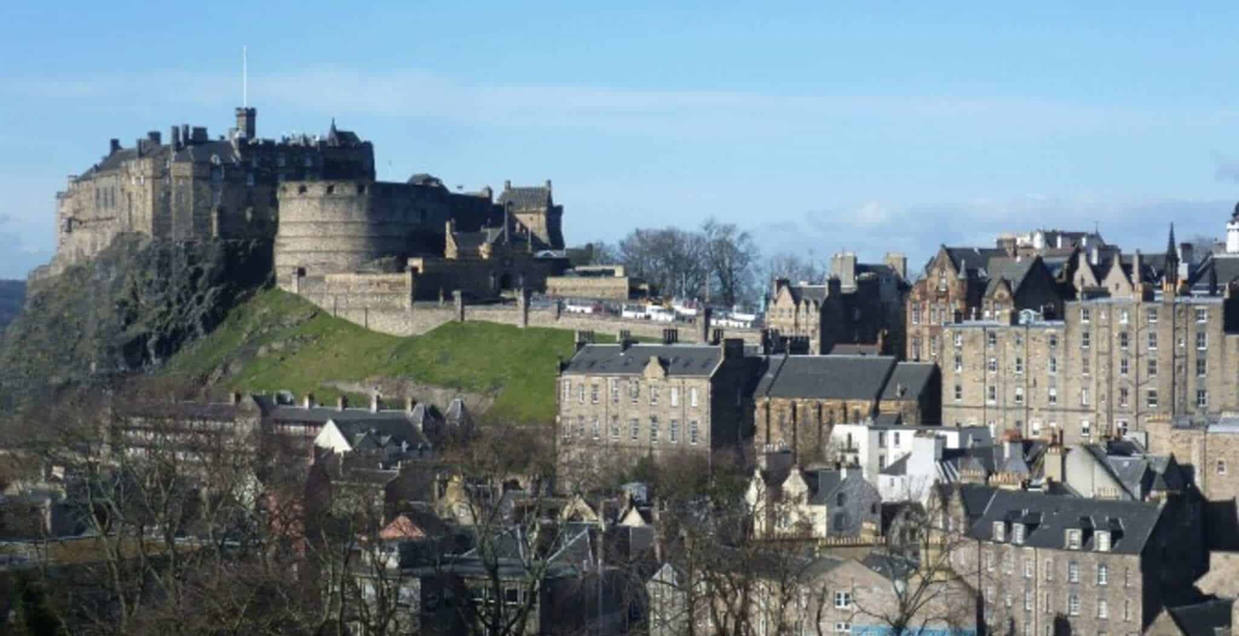

**Relevant Images**

Edinburgh

Belfast

Cardiff

London