Relationships and sex education (RSE) policy 2021
Catton Grove Primary School

Date of Policy: DRAFT
To be approved by Governors
March/ April 2021
Next review due by:

This relationships and sex education policy covers Catton Grove Primary school’s approach to teaching relationships and sex education (RSE). It was produced following thorough consultation with the whole school community including pupils, parents/carers, staff, school governors.

It will be reviewed every three years, or sooner if the RSE curriculum is amended, in response to emerging themes, changing pupil needs, or introduction of new legislation and guidance.

Parents will be informed about the policy through annual RSE consultation events, referencing in the school prospectus and a link from the school website. If a hard-copy of the document is required the school will be happy to provide this upon request. The school will work with parents requiring the policy in an alternative format, ensuring equitable accessibility for all.

Values, aims and objectives:

Relationships and sex education (RSE) is learning about the emotional, social and physical aspects of growing up, relationships and reproduction. It will equip children and young people with accurate
information, positive values and the skills to enjoy healthy, safe and positive relationships, to celebrate their uniqueness and to take responsibility for their health and wellbeing now and in the future.

RSE is taught in a way which is complementary to the wider ethos, values and principles of our school. RSE in this school is learning about the body, feelings, beliefs, relationships, rights and responsibilities and knowing how and when to ask for help if needed. It involves acquiring information, developing skills and forming positive beliefs, values and attitudes.

RSE empowers children to build self-esteem, offer positive and open views, support mutual respect and celebration of self and others, providing a strong foundation to be successful in life by:

✔ Providing a spiral curriculum, allowing for the development of knowledge relevant to the age and stage of the learner.

✔ Providing an inclusive learning environment which is safe and empowering for everyone involved, based on the belief that bullying, prejudice and discrimination is unacceptable.

✔ Teaching non-biased, accurate and factual information that is positively inclusive.

✔ Developing character skills to support healthy and safe relationships, ensure comfortable communication about emotions, bodies and relationships using appropriate terminology.

✔ Promoting critical awareness of differing attitudes and views presented through society, the media and peers to enable the nurturing of personal values based on respect.

✔ Providing protection from shock or guilt.

✔ Actively involving pupils as evaluators to ensure relevance.

✔ Ensuring pupils are informed of their rights, including the legal framework and how to access confidential help to keep themselves and others safe.

The RSE curriculum has been planned following pupil consultation. This ensures the needs of all pupils can be met through the delivery of an age and stage-appropriate curriculum. The curriculum addresses traditional and emerging issues, and relevant challenges as identified by pupils. Consultation with pupils will be conducted on a regular basis. This will inform the RSE curriculum review, ensuring it remains responsive to emerging needs.

Some elements of the RSE curriculum are a statutory requirement to teach in order for the school to meet RSE Guidance, 2020 and The Equalities Act, 2010. It is important to teach RSE through a spiral curriculum. This means pupils will gain knowledge, develop values and acquire skills gradually by re-visiting core themes to build on prior learning. This developmental approach helps pupils to make informed decisions relevant to their age and stage. RSE will support the school’s commitment to safeguard pupils, preparing them to live safely in the modern world.

Our intended RSE curriculum is detailed as follows but may vary in response to emerging issues and to reflect the rapidly changing world in which our pupils are living and learning. If this is the case parent/carers will be provided with appropriate notice before the amended programme is delivered. Where possible the curriculum will be complemented by themed assemblies, topic days and cross-curricular links.

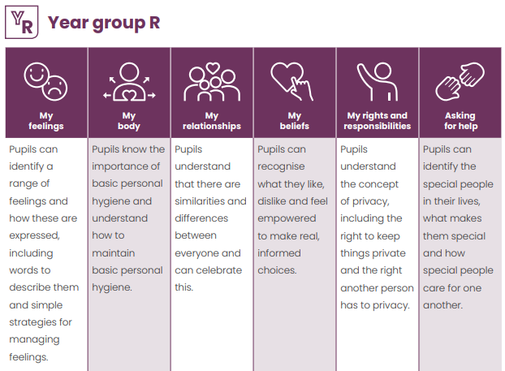

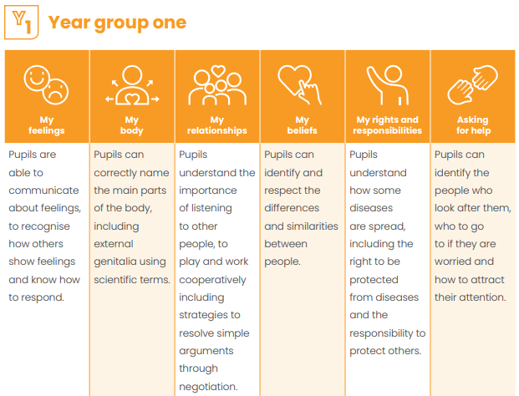
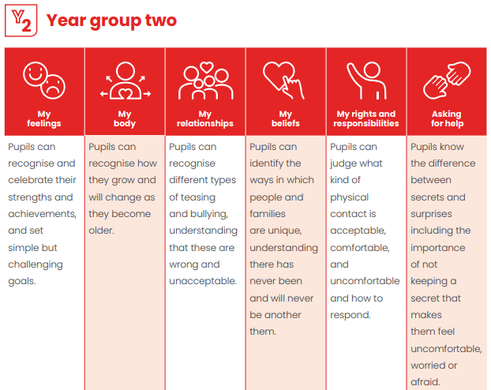
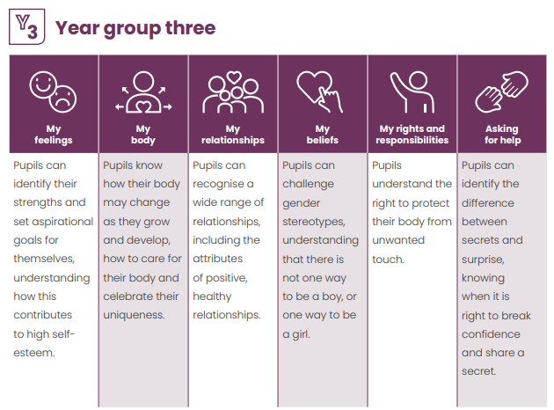

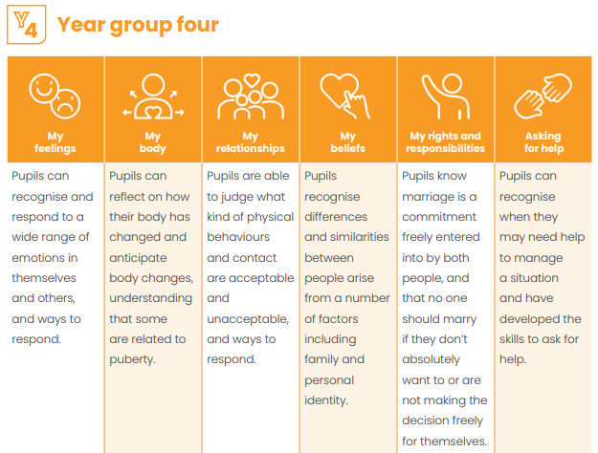

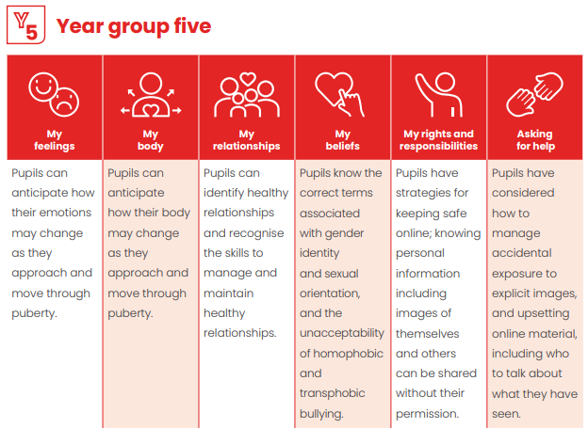

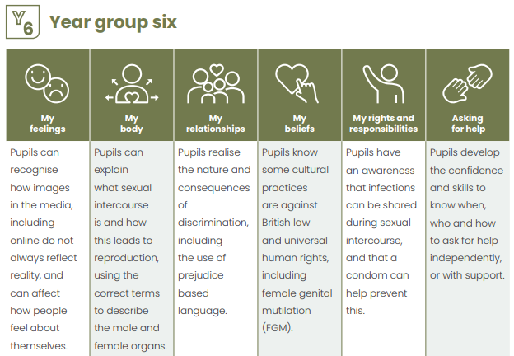

The RSE programme will be led by Joanna Gately and taught by Teachers and TAs and supported by visitors and outside agencies. Claire Shenton, Deputy Head will oversee the leading of the programme. All staff involved in the delivery of RSE have received specialist training ensuring pupils are taught with consistent approaches to RSE throughout their time at Catton Grove Primary School.

RSE will be taught using a range of teaching methodologies including story-telling, drama, discussions, individual private reflection, quizzes, fact finding, value spectrums, debating, independent research and artistic presentations etc. This wide range of teaching strategies promotes engagement by all pupils, irrespective of preferred learning styles. Distancing techniques, such as the use of characters within RSE, avoids pupils feeling under pressure to participate or disclose information beyond that which is appropriate or feels comfortable. This strategy makes RSE more accessible to all pupils, including those who may have experienced unhealthy relationships and/or abuse. The school’s responsibility to safeguard pupils through a curriculum that prepares them to live safely in the modern world will remain central to curriculum content, teaching methodologies and supporting resources.

At Catton Grove Primary School we actively celebrate the diversity of our pupils, their families and the wider whole school community. RSE will always be taught in a non-judgemental, non-biased and fully inclusive manner through clear, impartial, scientific information as well as covering the law. Through consultation, continual assessment and regular reviews of the curriculum, we ensure that we continually recognise and respect pupils’ different abilities, levels of maturity and personal circumstances including gender identity, faith or culture and that of their family, friends and the wider whole school community.

At the end of every lesson, pupils will be provided with an opportunity to ask questions as a class and can also ask anonymous questions through the use of an ‘ask it basket’. Teachers will answer questions as fully as they feel is age and stage-appropriate, based on the level of knowledge demonstrated by pupils during the lesson. Teachers may ask a pupil to wait for a response to a question if they need time to consult with a colleague, or the school leadership team, to construct an appropriate answer. Teachers can refuse to answer a question that they feel is inappropriate. Teachers will not answer personal questions about their own body, personal circumstances or lifestyle choices. If a teacher does not answer a question, the pupil will have the reasons for this decision clearly explained. The teacher will work with the pupil to identify suitable sources of information, where they can safely obtain an answer to their question.

At the end of every lesson, teachers will signpost pupils to information relevant to the topic being taught to ensure safe sources of information, advice and guidance are provided. Teachers will also work closely with the schools' pastoral system to advise of topic coverage. This will ensure the school can be responsive to pupils’ pastoral needs, and safeguarding arrangements can be actioned efficiently if required. If the school has any reason to believe a pupil is at risk of harm, we are required to respond in accordance with the school’s safeguarding policy.
Pupils’ learning will be assessed at the end of every topic. This will ensure that pupils are making sufficient progress building on prior teaching and learning and that teaching strategies and resources remain relevant and effective. Assessment activities will be implicit, forming part of a normal teaching activity to ensure that pupils do not feel under pressure. The evaluation of teaching and learning assessments will be shared with pupils and parents as appropriate.

RSE is most effective when it is a collaboration between school and home. The school will provide support to parents and carers through an annual event, providing a valuable opportunity to develop awareness of emerging RSE topics, meet RSE teachers, review the resources being used and consider ways to build on RSE at home. The school operates an open-door policy enabling parents to discuss RSE at relevant times throughout the school year.
This policy complements the following policies:

- Anti-bullying

- E-safety

- Equality

- Inclusion

- PSHE

- Safeguarding

- Teaching and learning

