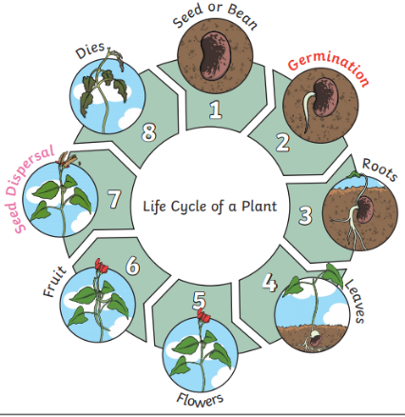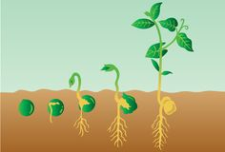

**How to Conduct a Scientific Experiment**

1. Make an observation

2. Ask a question

3. Think of a hypothesis

4. Experiment

5. Record the results

6. Discuss the results and make a conclusion

**Key Vocabulary**

Seed bulb plant root stem flower leaves germination sprout shoot seed dispersal sunlight water temperature nutrition

**Relevant Images**

**Year 2 Knowledge Organiser**

Spring 1 – Science; Plants

**Science - What should I already know?**

I know that science is about questions and investigations.

I know how to think of questions and answers about the world around me.

I know that plants are living things.

I know that I can find answers by experimenting.

I know that there are different kinds of places in the world with different living things in them.

I can begin to compare plants to other living things.

**Enquiry Questions**

What do plants need in order to grow?

Can plants grow without all their basic needs being met?

Do some plants grow in different environments to others?

What do plants need in order to remain healthy?

Do all living things have basic survival needs?



<https://www.natgeokids.com/uk/discover/geography/general-geography/what-is-climate-change/>

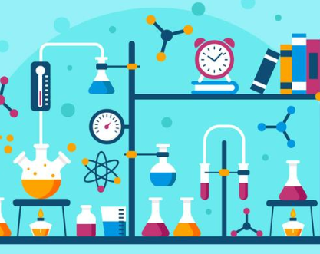

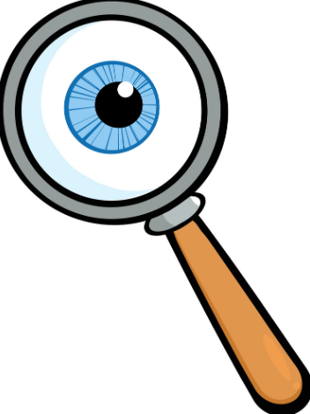<https://climatekids.nasa.gov/>

**Essential Facts**

Plants are a living thing.

Plants start as seeds or bulbs; they grow into plants.

Plants have basic needs in order to grow and remain healthy.